**TEAM ID**: PNT2022TMID24844

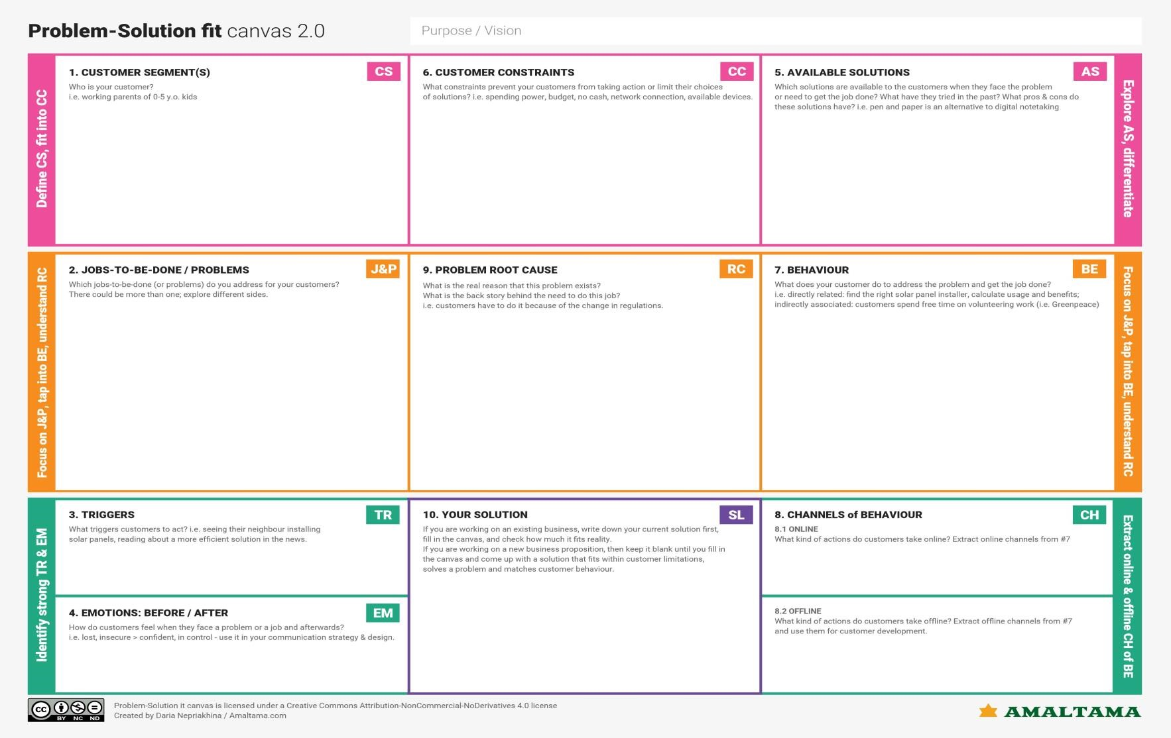

•

Pedestrians

•

Passengers

•

Transportation operators

•

Displays

Speed limit

depend on weather

condition and during

abnormal situations.

•

Displays status of road condition.

•

Dynamic sign change.

Act according to the information that displayed on smart board.

Control the speed of the vehicle depends on the speed alert

•

BEFOR

E

:

Feels tensed,

confu

sed and insecure while driving

•

AFTER:

Feels safe and co

mfortable.

Road signs are static

which

needs manual replacement for abnorm

al

conditions.

Limited

number of autonomous vehicle usage.

•

I

t

is a low

cost n

etworking system

.

•

IO

T devices are managed in cloud so

operators

can

have a database

.

•

U

se of solar power to provide

power source makes renewa

b

le system

.

•

Environmental Changes

.

•

Manual mistakes due to lack of concentration.

•

Lack of Visibility.

•

Proper Education and Training

.

•

Focused

driving

.

•

Avoid dr

u

nk

a

nd

drive

.

We employ

Dynamic smart signs

as an alternative t

o static sign boards.

Weather API

are need to be implemented to monitor the

environmental

conditions

such as rainfall, air pollution, fog

.

R

oad infrastructure

like

congestion, breakdown

and

vehicle information

like speed

, lane monitoring

,

vehicle position

are managed by

using cloud

monitoring syste

ms.

Works

effectively

to avoid accident

and traffic

congestion in

order to

achieve

a safe

journey

.

They must register in

the platform

for communication with administrator.

Follow

s

the instruction

displayed on the smart board.

**Signs with**

**Smart**

**Connectivity for better Road Safety**